PLC (PROGRAMMABLE LOGIC CONTROLLER)

What is an PLC?
A programmable logic controller, or PLC, is an industrial computer that monitors inputs, makes decisions based on its programmed logic, and controls outputs to automate machines or processes. These systems are built to operate reliably under harsh industrial environments like extreme temperatures, vibrations, and electrical noise
Key Functions of PLCs:
- Input Handling: Collects real-time data from sensors and switches.
- Processing: Executes the user-defined program logic.
- Output Control: Sends commands to devices like motors and actuators.
- Monitoring: Continuously observes system performance and updates accordingly.
A PLC system is the proper setup that includes the programmable logic controller, its software, and the input/output modules that connect it to machinery and sensors. The controller reads signals from the environment, applies programmed instructions, and manages connected devices.

Main Components of a PLC System:
- Central Processing Unit (CPU): Executes control instructions.
- Input Modules: Receive signals from sensors and switches.
- Output Modules: Activate machines and equipment.
- Power Supply Unit: Provides necessary electrical power.
- Programming Device: Allows the user to enter logic instructions.
The PLC controller is the core device that interprets and processes input data, executes logic instructions, and controls output devices accordingly. It consists of the CPU, memory, and communication ports.

Role of a PLC Controller:
- Data Collection: Gathers data from field devices.
- Logic Execution: Processes instructions based on programmed logic.
- Command Execution: Activates outputs like solenoids or motors.
- Status Communication: Shares system information with operators or supervisory systems.
Essentially, when people refer to the PLC, they are typically talking about the controller that coordinates all operational actions.

How PLC Works?
The operation of a PLC follows a clear and repetitive cycle known as the scan cycle. Now, let's understand how PLC works. During each cycle, the PLC:
- Reads the status of all input devices connected to it.
- Executes the control program stored in its memory.
- Updates the status of output devices based on the program results.
This cycle occurs within milliseconds, allowing for real-time process control. The predictability of the scan cycle makes PLCs a preferred choice for automation tasks where timing and sequencing are critical.

PLC Working Principle
The PLC working principle is based on a continuous process known as the scan cycle. During this cycle, the controller reads inputs, processes logic, and updates outputs almost instantly.
Stages of the Scan Cycle:
- Input Scan: Detects the status of all input signals.
- Program Execution: Runs the control logic stored in memory.
- Output Update: Changes output states based on the program results.
- Housekeeping: Performs internal checks and communications.
Choosing the Right PLC for Your Application
Selecting the right PLC involves evaluating several critical factors based on the needs of the PLC applications.
- I/O Requirements: Determining the number and type of inputs and outputs needed.
- Processing Speed: Ensuring the CPU can handle the control logic complexity.
- Environmental Conditions: Choosing models that withstand temperature, dust, or moisture.
- Expandability: Selecting a PLC that allows for future system growth.
- Software Compatibility: Confirming the PLC works with your programming and monitoring tools.
Picking the right PLC helps in building a control system that is trust, scalable, and low-priced for your specific tasks.

Advantages and Disadvantages of PLC
Here are the advantages and disadvantages of PLC:
Advantages of PLC:
- PLCs are highly reliable due to their solid-state design with no moving parts.
- They offer flexible programming, allowing changes without rewiring the system.
- Small size, easy installation, and modular construction make them scalable.
- PLCs consume very low power compared to mechanical relay-based systems.
- They provide better diagnostic and troubleshooting capabilities via built-in status indicators.
Disadvantages of PLC:
- High initial setup and equipment costs for large-scale systems.
- Specialized training is often needed for programmable logic controllers, programming methods, and applications.
- PLCs can be less efficient for handling very complex analog operations.
- Different manufacturers use proprietary software, which limits system compatibility.
- Maintenance of old or obsolete PLC models becomes difficult due to a lack of support.

Brands of PLC
There are lot of PLC manufacturers, some of the commonly known brands of PLC are;-
- Allen Bradley (AB)
- Siemens
- ASEA Brown Boveri
- Omoron
- GF Fanuc
- DELTA
- Mitsubishi
- Messung
- Keyence
In all the brands there may be the different types of PLCs available.

Main Types of PLCs Based on Size
PLCs are available in many sizes, depending on the job they have to do.
PLC Size | Description | Common Use
Nano PLC | Very small, few inputs and outputs | Simple machines
Micro PLC | Small but more flexible | Small assembly lines
Medium PLC | Handles complex tasks | Factory automation
Large PLC | High capacity, thousands of I/O | Power plants, big industries

PLC Control System
A PLC control system combines hardware and software elements to monitor and control industrial processes automatically. It reads input conditions, processes the data, and controls outputs based on a prewritten set of instructions.
Main Elements of a PLC Control System:
- Sensors: Provide real-time input signals.
- CPU: Processes the input and applies the programmed logic.
- Outputs: Actuators like motors, lights, or alarms driven by decisions.
- Communication Interfaces: Link the PLC to other devices like HMIs or SCADA systems.
This coordinated system allows industries to automate complex tasks while maintaining flexibility for future modifications.
Types of Inputs in PLC Systems
Inputs are critical for a PLC to gather information about its environment. Inputs provide the signals needed for the PLC to make decisions.
- Digital Inputs: Detect simple ON/OFF signals from buttons or switches.
- Analog Inputs: Measure variable signals like temperature, pressure, or speed.
- Specialty Inputs: Include devices such as encoders or RTDs for specialised sensing.
- Wireless Inputs: Transmit data via wireless communication where cabling is impractical.
- Remote Inputs: Connect inputs from distant locations using network modules.
Inputs define how the PLC reads real-world conditions, enabling accurate and timely system control.

Communication Options for PLCs
Modern PLCs support multiple communication options for better integration and monitoring. These options allow seamless system expansions and remote supervision.
- Ethernet/IP: Common industrial networking protocol for real-time data sharing.
- Modbus: Open protocol used widely across automation devices.
- PROFIBUS: High-speed protocol for complex automation systems.
- DeviceNet: Simplifies the connection of control devices like sensors and actuators.
- Wireless Protocols: Enable communication in environments where wired setups are difficult.
Strong communication capabilities make PLCs ideal for smart manufacturing and connected automation ecosystems.

Types of Outputs in PLC Systems
Outputs are the devices that receive control instructions from the PLC. Outputs perform actions based on the logic executed.
- Digital Outputs: Turn devices ON or OFF, such as motors, lights, or alarms.
- Analog Outputs: Control variable devices like valves or variable-speed drives.
- Relay Outputs: Provide electrical isolation between control and power circuits.
- Solid-State Outputs: Offer faster switching and longer life compared to mechanical relays.
- Networked Outputs: Control remote actuators through industrial communication networks.
Outputs convert the PLC’s logical decisions into real-world mechanical or electrical operations.

Why are PLCs used in industrial automation?
We have multiple reasons to use PLCs such as: improving the efficiency and reliability of industrial processes, reducing the cost and complexity of wiring and hardware, and enabling easy reconfiguration and modification of the control logic.
PLCs are specialized computers that can monitor and regulate machines and manufacturing processes in various environments with automation technology.
They can perform discrete and continuous functions, such as timing, counting, calculating, comparing, and processing various analog and digital signals. PLCs are also designed to operate reliably under harsh industrial conditions, such as extreme temperatures, humidity, and vibration.

Flexibility and Adaptability:
One of the primary reasons for the widespread use of PLCs in automation is their unparalleled flexibility and adaptability. Unlike traditional control systems that require extensive rewiring for modifications, PLCs allow engineers to alter control logic through programming. This flexibility ensures that manufacturing processes can be easily adapted to accommodate changes in product specifications or production requirements.

Real-time Control:
PLCs excel in providing real-time control over industrial processes, a crucial requirement in modern manufacturing. Whether it’s regulating the speed of a conveyor belt, monitoring temperature variations in a furnace, or coordinating complex assembly line tasks, PLCs execute commands with precision and immediacy. This real-time responsiveness is vital for maintaining the integrity of production timelines and ensuring optimal efficiency.

Customization for Specific Industrial Needs:
The ability to customize control logic makes PLCs indispensable for addressing specific industrial needs. Different industries have distinct requirements, and PLCs can be programmed to cater to these specific demands. From automotive manufacturing to food processing, the adaptability of PLCs ensures that they seamlessly integrate into diverse industrial settings.

Reliability and Durability:
In the harsh environments of industrial facilities, reliability is non-negotiable. PLCs are renowned for their robustness and durability, making them well-suited for the demanding conditions of manufacturing plants. Their design incorporates features like resistance to dust, moisture, and temperature extremes, ensuring uninterrupted operation even in challenging settings.

Improved Diagnostics and Troubleshooting:
PLCs simplify the diagnostic and troubleshooting processes in industrial automation. With detailed feedback on the status of input and output signals, engineers can quickly identify issues and rectify them. This capability reduces downtime and enhances overall system reliability, a crucial factor for industries where every minute of operation translates to productivity and profit.

Cost-effectiveness:
While the initial investment in PLCs might seem substantial, their long-term cost-effectiveness is undeniable. The adaptability and ease of reprogramming mean that changes in production processes can be implemented without significant additional costs. Additionally, the reduction in downtime and improved efficiency contribute to cost savings over the operational life of the PLC system.

Integration with Other Automation Technologies:
PLCs seamlessly integrate with other automation technologies, such as SCADA systems, to create comprehensive control solutions. The interoperability of PLCs allows for a unified approach to industrial automation, where different components work in tandem to optimize processes. This integration capability positions PLCs as a central component in the broader ecosystem of automation technologies.

Advantages of PLC over traditional relay control systems.
1. Compact design
2. Reduced hardware complexity
3. Multi-functional capability: A PLC can function as a timer, counter and comparator.
4. Easy logic modification through software without a physical rewiring.
5. Simplified Wiring.
6. More reliable than relays.
7. PLCs have built-in memory and computational capabilities, enabling them to execute more complex tasks than that of relays.
8. PLCs can withstand vibrations, temperature variations, and humidity far better than traditional relays.
9. Troubleshooting faults in PLC systems is much simpler and faster.

Basic PLC architecture
Functions of :-
CPU :- The CPU serves as the brain of the PLC, executing the control program and coordinating all system operations. It contains the Arithmetic Logic Unit (ALU), which processes input data, applies logical instructions, and generates the required outputs. The control unit present in the CPU helps with sequencing and internal timers/counters.
- Processor: Executes ladder logic, function block, or structured text programs
- Scan Cycle: Continuously reads inputs, executes logic, and updates outputs (typical scan times: 0.5-10ms per 1K instructions)
- Task Management: Handles multiple program tasks, periodic tasks, and event-driven routines
- Processing Speed: Modern CPUs operate at 10-100 MHz, with cycle times measured in microseconds

Memory :- PLC contains the memory unit for storing the user program, operating system, and data. It includes the memories like RAM (temporary storage) and ROM/EEPROM (permanent program storage).

Power Supply :- Power supply module ensures a stable power supply is provided, even under electrical disturbances or not. It provides 24V DC voltage to operate the CPU and input/output modules.
Converts incoming AC power to DC voltages required by CPU and I/O modules.
- Input Voltage: Typically 120/240VAC or 24VDC depending on model
- Output Voltages: +5VDC (logic), +24VDC (I/O driver)
- Current Rating: 2-10A depending on system size
- Isolation: Galvanic isolation between field and system power

Input Modules :- Receive signals from field devices such as sensors, switches, and push buttons, and convert them into signals the CPU can use.

Output Modules :-Send control signals from the CPU to field devices like motors, relays, valves, and lights.

Difference between Digital Input and Digital Output
Feature | Input | Output
Functions | Receives binary signals from field devices to relay a status or condition to a controller. | Sends binary commands from a controller to trigger or control an external device.
Direction of Data | From the user or external source into the computer | From the computer out to the user or another device
Control | Controlled directly by the user | Controlled by the computer
Data Translation | Converts user actions into machine-readable (binary) code | Converts machine code into a human-understandable format
Common Examples | Keyboard, mouse, microphone, scanner | Monitor, printer, speakers, projector

Draw and explain a basic PLC Block Diagram.
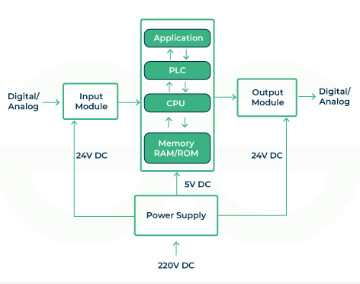

Main Components of a PLC
Their are mainly 6 major part of a PLC that are :
- Processor
- Memory(RAM/ ROM)
- Input device
- Output device
- Power supply
- Programming device
Description of each part of a PLC :
- CPU : CPU is the brain of a PLC, responsible for executing the control program stored in memory. It performs tasks such as data processing, decision-making and communication with other devices.
- Memory(RAM/ROM) : PLCs have main type of memory one is ram and another is rom. RAM is used for storing data and variables temporarily during the execution of the program. ROM is used to store the operating system of a PLC and the user program. The program typically consists of two ladder logic, function block diagrams or other programming languages.
- Input Device : This is responsible for interacting with the machine and the instructor which can be external sensors, switches etc. This part helps to take input and send to to the CPU to response accordingly.
- Output Device : Output device is responsible for interacting with the end point external device like motor, valve or indicator. It converts control signal from the PLC that these devices can interpret.
- Power Supply : PLC requires a stable power supply to run its program and match the voltage levels that needed for a PLC components.
- Programming Device : As PLC is mainly a programmable device, so we need a device where we can write code and execute it, just like a monitor and keyboard.

Working of PLC controller
- Their are main four part of a PLC, input and output module, controller and a power supply.
- First supply current goes to the power supply machine which is 220v AC, later it is divided into three parts and converts it from AC to DC. Both of the two input and output module takes 24v DC current and the main controller part takes 5v DC current.
- Input part takes signal from sensor and other devices, and passes it to the PLC main part.
- The main controller part sends the signal to the CPU, then starts executing its program in compiler from the memory. After that the program creates an instruction signal, which goes to the output module.
- The output module receives type signal and sends it to the external devices like motor, valve etc. which will execute the instruction by controlling the system according to the instruction.

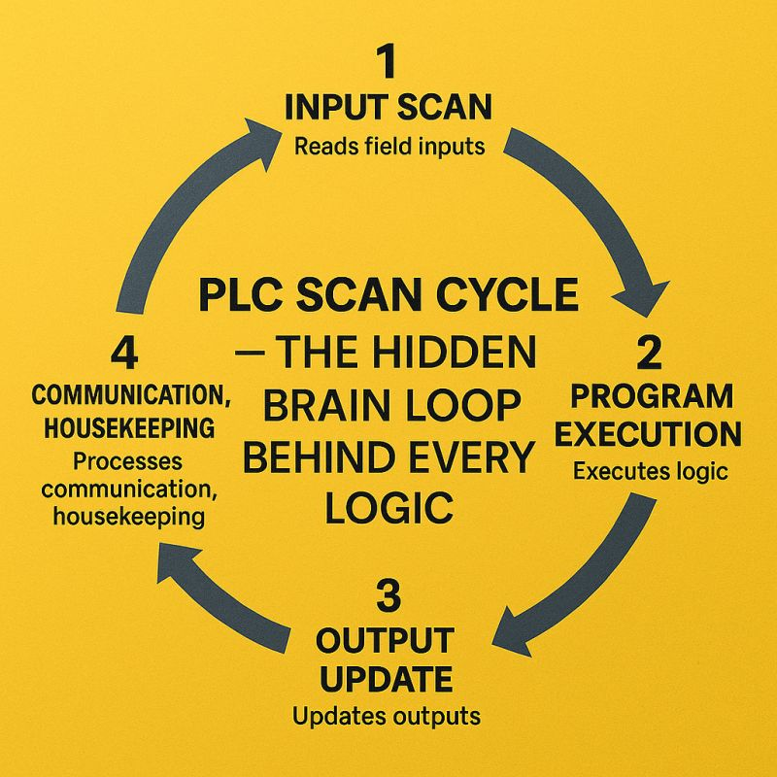
Explain the PLC scan cycle with a suitable diagram.
The PLC (Programmable Logic Controller) scan cycle is the sequence of operations that a PLC repeatedly performs to monitor inputs, execute the control program, and update outputs. Understanding the scan cycle is crucial for designing and troubleshooting PLC-based automation systems.

Main Steps in the PLC Scan Cycle
- Input Scan: The PLC reads the status of all input devices (e.g., sensors, switches) and stores their states in memory.
- Program Execution: The PLC executes the user program (ladder logic, function block, etc.) using the input data stored in memory.
- Output Scan: The PLC updates the status of all output devices (e.g., actuators, relays) based on the results of the program execution.
- Communication/Housekeeping: Finally, the PLC exchanges data with HMIs, other PLCs, and performs internal diagnostics before starting the next cycle.
- Continuous Scanning Process: A PLC does not normally execute its control program only once. Instead, it repeatedly scans the inputs, executes the program, and updates the outputs as long as it remains in RUN mode.

Key Points
- The scan cycle repeats continuously and rapidly.
- Inputs are only updated at the start of each cycle; outputs are updated at the end.
- The scan time (duration of one cycle) depends on program complexity and PLC speed.
This cycle ensures that the PLC can reliably monitor and control industrial processes in real time.

5 industrial devices
Industrial Devices | Type
Push Button | Digital Input
Temperature sensor | Analog Input
Pressure Sensor | Analog Input
Solenoid Valve | Digital Output
Emergency Stop Button | Digital Input

